Estimating Weather Elements withing Kingdom Of Saudi Arabia

Using GIS Spatial Interpolation analysis

By : Eng. Mohammed AlQahtany

The Weather elements I want to estimate are:

1-Temperature in Celsius

2- Wind Speed in Km/Hour

3- Humidity in %

I would like to estimate the Weather Temperature, Wind speed and Humidity in 5 cities : Jeddah , Mecca , Rabigh , Al-Jubail , and Sharurah , I chose them randomly just to test my analysis

I don’t know the Weather Elements in these cities but GIS will help me to estimate the temperature , Wind speed and Humidity !

Using the other cities data which I look them up in (weatherAccurate.com) and I enter them manually. And on purpose I didn't enter the data for the 5 cities to estimate them myself using GIS . see the attribute table below:

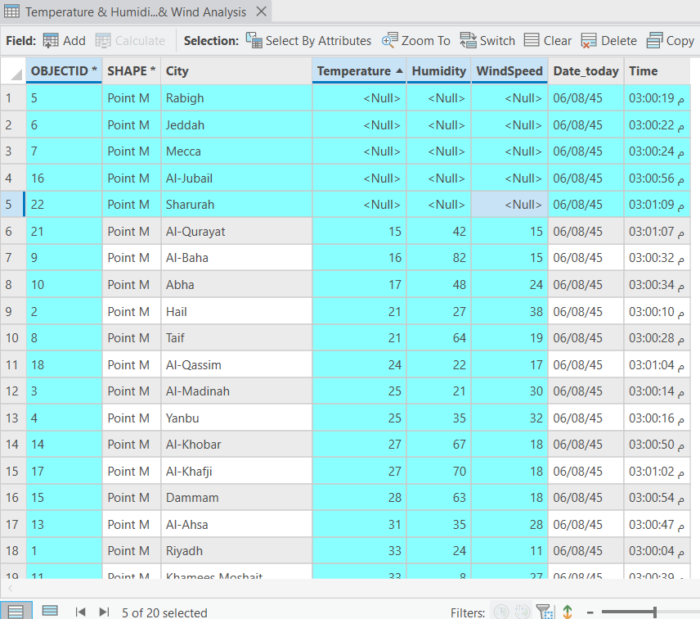

As you can see the other cities data are entered using the following weather forecasting website:

https://www.accuweather.com/

(The Data taken exaclty on 16 February 2024 at 3:00 pm)

Using GIS spatial Interpolation analysis tools:

صورة تحتوي على نص, خريطة

تم إنشاء الوصف تلقائياً

The Blue cities above are the cities that I want to estimate their temperature, it's not so accurate as reality but it's affective!

So for Rabigh it's between 22-23 degrees

Jeddah and Mecca are between 19-22 degrees

Jubail is between 26-27 degrees

And finally Sharurah is between 27-30 degrees

صورة تحتوي على نص, خريطة

تم إنشاء الوصف تلقائياًNow let's do the Wind Speed in the 5 cities

Wind speeds as following:

Rabigh between 21-24 KM per hour

Jeddah between 18-20 KM per hour

Mecca between 16-18 KM per hour

Sharuran between 16-18 KM per hour

Jubail between 16-18 KM per hour

Next let's do the Humidity analysis!

صورة تحتوي على نص, خريطة

تم إنشاء الوصف تلقائياً

Humidity will be as following:

Rabigh between 38-44%

Mecca , Jeddah and Jubail are between 53-65%

Sharurah is between 29-33%